EXERCISE-3
PL/SQL-Stored procedures
Create accounts table and insert values
CREATE TABLE Accounts (
AccountID NUMBER PRIMARY KEY,
CustomerName VARCHAR2(50),
AccountType VARCHAR2(20),
Balance NUMBER(10,2)
);
INSERT INTO Accounts VALUES (1001,'Rahul','Savings',10000);
INSERT INTO Accounts VALUES (1002,'Priya','Savings',15000);
INSERT INTO Accounts VALUES (1003,'Amit','Current',20000);
INSERT INTO Accounts VALUES (1004,'Sneha','Savings',25000);
COMMIT;

Create employees table and insert values
CREATE TABLE Employees (
EmployeeID NUMBER PRIMARY KEY,
EmployeeName VARCHAR2(50),
DepartmentID NUMBER,
Salary NUMBER(10,2)
);
INSERT INTO Employees VALUES (101,'John',1,50000);
INSERT INTO Employees VALUES (102,'Alice',1,60000);
INSERT INTO Employees VALUES (103,'Bob',2,55000);
INSERT INTO Employees VALUES (104,'David',2,65000);
COMMIT;
Scenario 1: The bank needs to process monthly interest for all savings accounts.
  - Question: Write a stored procedure ProcessMonthlyInterest that calculates and updates the balance of all savings accounts by applying an interest rate of 1% to the current balance.
CREATE OR REPLACE PROCEDURE ProcessMonthlyInterest
AS
BEGIN
UPDATE Accounts
SET Balance = Balance + (Balance * 0.01)
WHERE AccountType = 'Savings';

COMMIT;
END;
/

BEGIN
ProcessMonthlyInterest;
END;
/

SELECT * FROM Accounts;
OUTPUT;
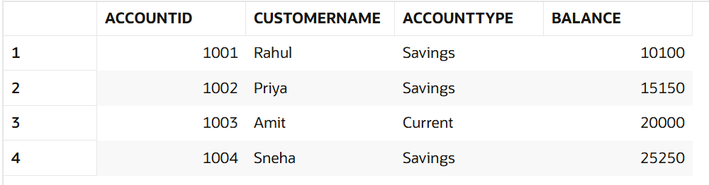
Scenario 2: The bank wants to implement a bonus scheme for employees based on their performance.
  - Question: Write a stored procedure UpdateEmployeeBonus that updates the salary of employees in a given department by adding a bonus percentage passed as a parameter.
CREATE OR REPLACE PROCEDURE UpdateEmployeeBonus
(
p_DepartmentID NUMBER,
p_BonusPercent NUMBER
)
AS
BEGIN
UPDATE Employees
SET Salary = Salary + (Salary * p_BonusPercent / 100)
WHERE DepartmentID = p_DepartmentID;
COMMIT;
END;
/
BEGIN
UpdateEmployeeBonus(1,10);
END;
/
SELECT * FROM Employees;
OUTPUT:

Scenario 3: Customers should be able to transfer funds between their accounts.
  - Question: Write a stored procedure TransferFunds that transfers a specified amount from one account to another, checking that the source account has sufficient balance before making the transfer.
CREATE OR REPLACE PROCEDURE TransferFunds
(
p_FromAccount NUMBER,
p_ToAccount NUMBER,
p_Amount NUMBER
)
AS
v_Balance NUMBER;
BEGIN

SELECT Balance
INTO v_Balance
FROM Accounts
WHERE AccountID = p_FromAccount;

IF v_Balance >= p_Amount THEN
UPDATE Accounts
SET Balance = Balance - p_Amount
WHERE AccountID = p_FromAccount;
UPDATE Accounts
SET Balance = Balance + p_Amount
WHERE AccountID = p_ToAccount;

COMMIT;

ELSE
DBMS_OUTPUT.PUT_LINE('Insufficient Balance');
END IF;

EXCEPTION
WHEN NO_DATA_FOUND THEN
DBMS_OUTPUT.PUT_LINE('Account Not Found');

WHEN OTHERS THEN
ROLLBACK;
DBMS_OUTPUT.PUT_LINE(SQLERRM);
END;
/
BEGIN
TransferFunds(1001,1002,5000);
END;
/
SELECT * FROM Accounts;
OUTPUT:
